Exercise 2

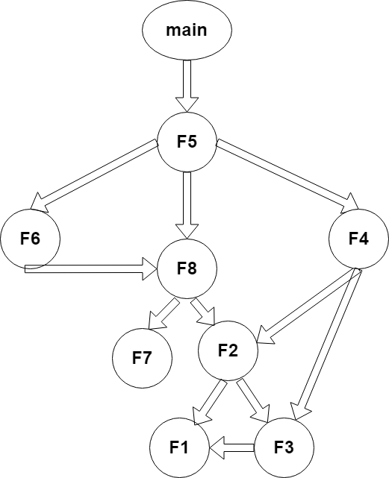

This diagram represents all the functions alongside their descendants and parents.

1. With 3.74 seconds of Self Seconds as seen in the data, the function with most exclusive execution time is F7 due to the fact that it has the maximum number of self-seconds.

With a total call 260 which were all by its one and only parent F8, F7 is the most suitable function to be parallelized.

1. The speed up is total sequential time / exclusive time :5.38/3.74 =1.44s

For the efficiency E(p)= S(p)/p and I my case I have 8 cores

So therefore 1.44/8 = 0.18

1. The function is called 260 times
2. It calls no other function.
3. The most called function is F1 with a total number of 5551 calls. it’s being called by F3 and F2.
4. The computation time of F5 is composed of number of seconds spent inside the function which is literally including its children multiplied by the number of times the function is called.